2017/2018 Membership Form
ABN 57 37 123 4081
Driver Details
Name
Address
D.O.B
Speedway Australia #
Car #
Top Star/New Star
Parent/Guardian Details
Name
Address
Email
Contact #
Speedway Australia #
For a driver to compete in one or both series they must nominate for that series and be a member of the club.
- All cars must be WASCF registered and all drivers must have current Speedway Australia license
- Car Numbers will be issued by the JSRA and cars MUST run the JSRA number on their roof plate to be eligible for points.
- All members agree to comply with Speedway Australia rules and policies.
- Original forms can be mailed to
JSRAWA
PO Box 755
Morley WA 6943.
Or Emailed to kderrick@westnet.com.au
All Drivers MUST have a Parent/Guardian member of the JSRA and who holds a current Speedway Australia License.

Tick which series option you would like to compete in below-
Select |  |  | Amount Payable
 | Motorplex Series | $ 30
 | Country Super Series | $ 60
 | Both Motorplex & Country | $ 80
 | Driving Member (Compulsory) | $ 25
 | Parent/Guardian Member (Compulsory with each driver) | $ 20
 | Non-driving Member- for additional adults/children that would like to join | $ 20
 | Poster-See Notes below | $ 50
 |  | TOTAL
NOTE: IF YOU WOULD LIKE TO BE INCLUDED ON THE PROMOTIONAL POSTER PLEASE TICK THE ABOVE POSTER SECTION AND ADD THE $50 TO YOUR MEMBERSHIP. A PHOTO OF YOUR CAR MUST BE INCLUDED WITH YOUR MEMBERSHIP. YOU WILL RECEIVE A PACKAGE OF POSTERS (MULTIPLE) TO HAND OUT TO PEOPLE OF YOUR CHOICE.

In order to receive your end of season Trophy’s, prizes and tow monies you MUST attend the end of season trophy night.

Payment Details
Payment to be cash in person or direct to:
Bank Commonwealth Bank
BSB 066-167
Account No 10421008
Account Name Junior Speedway Racing Association of WA
(Please use surname as reference)
To Be Completed by Applicant
I wish to apply for membership of the JSRAWA as a Driver/Non-Driver member. I agree to abide by the code of conduct, rules and regulations of the association.
Signature of Applicant:
To Be Completed by Parent or Guardian
I, (Parent/Guardian)
Hereby give my child entered above permission to become a Driver/Non-Driver member of the JSRAWA for the
2017/2018 season.
Signature of Parent/Guardian:
Office Use:
Birth Certificate Sighted: Yes/No for new members only
Date Received: //
Receipted No:
Car No:
Signature of Club Official:
Position Held:

Junior Speedway Racing Association of WA
2017/2018 season
Junior Drivers Code of Conduct
I , agree to abide by the following junior driver code of conduct as set down by the JSRA WA committee.
I am also aware that there is in place a Zero Tolerance Policy and I will be investigated by the JSRA WA committee should I break any of these codes of conduct
Never argue with an official. If you have an issue, complaint or protest approach the junior Pit
Marshall,
JSRA president, vice president or any executive committee member.
Abuse of an official, committee member will NOT be tolerated.
I will not verbally abuse any officials. sledge any other drivers or drive in an aggressive manner aimed at provoking or "getting even" with a fellow driver.
Be a good sport. Congratulate fellow drivers on good performances.
Have good sportsmanship if things don't go my way. No tolerance will be given to drivers swearing, throwing any items in temper during a race meeting
I will adhere to the rules and regulations of the venue that JSRA compete at during the 2016 / 2017 season.
I will treat all officials. volunteers, fellow drivers, their parents / families and pit crew with respect. I will not bully, intimidate, threaten or take unfair advantage of a fellow competitor.
Bullying, intimidation, threats of any form directed at any speedway driver, official. parent / guardian, family member or pit crew be it verbal, physical or in written form including ANY SOCIAL NETWORK site will be dealt with severely by the JSRA WA. Speedway Australia (Formerly NASR) and the WASCF.
Penalties will range from a warning to racings bans at ALL TRACKS WITHIN W.A.
These bans will range from a one meeting ban to an entire season depending on the severity of the offence. If the offence is serious enough to warrant further investigation it will be referred to the West Australian Police Service with the consent of the victim and their family
I will not approach any fellow driver, official, adult in an aggressive manner.
I will respect my fellow competitors, for without them there would be no competition.
Participate for your own enjoyment and benefit, not just to please parents and coaches.
Drivers Signature:
Date
Parent / Guardians signature:

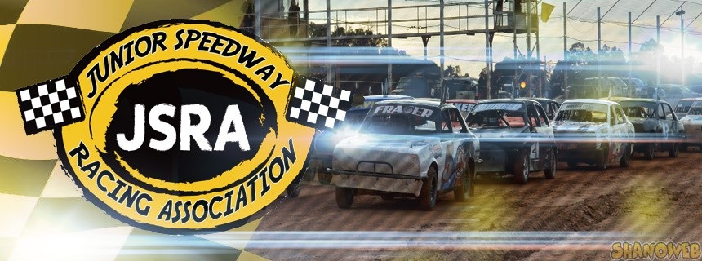

Junior Speedway Racing Association of WA
2017/2018 season
Parent / Guardian / Mechanic Code of Conduct
I, , promise to abide by this Code of Conduct as set out by the JSRA WA.
I also understand that should I break any of these codes I will be subject to investigation by the JSRA WA committee and may be penalized depending on the severity of the offence.
Remember that children participate in sport for their enjoyment, not yours.
Encourage children to participate, do not force them.
Focus on your child's efforts and performance rather than whether they win or lose.
Children will always compete according to the rules and to settle disagreements without resorting to hostility or violence.
Encourage good sportsmanship.
Remember that children learn best by example.
Appreciate good performance and skillful driving by all participants and not just your own child.
Support all efforts to remove verbal and physical abuse from speedway activities.
Respect officials' decisions and I will teach my child(ren) to do likewise.
Show appreciation for volunteers, officials and administrators. Without them, your child could not compete.
Never approach a junior driver or their parent(s) in an aggressive manner.
Never aggressively touch or abuse a junior driver or parent.
I will not bully, intimidate, threaten or take unfair advantage of a junior competitor, parent or guardian.
Remember we all make mistakes and no matter how hard we try to avoid them, accidents do happen!
Remember this is a JUNIOR sport and our children are not racing for "sheep stations."
Signature:  Parent / Guardian / Mechanic | Date / /

